Math 4 Honors Name _________________________

Lesson 5-4: *Counting and Multiplication Rules for Probability* Date __________________________

**Learning Goal:**

* *I can use counting methods to determine probabilities.*

**Write all final probabilities as fractions in lowest terms!**



When events are equally likely, the probability of event *A*, or *P*(*A*), is =

1 a. Yes or No? _______ Total number of possible outcomes = ______.

b. There are ______ favorable outcomes. List them: _________________________________________

c. Probability = ________ Put the fraction in lowest terms.

2 a. _____________________ different ways to fill out a ticket. Show work.

b. There is only _____ way to fill out a “Match + 1” ticket. The probability is ________________.

c. The probability of getting a “Match 5” winner is ____________________.

d. The probability of getting a “Match 4 +1” winner is ____________________. Show work.

3 a. There are ________ outcomes possible. Show work.

b. Use any method for these. Show work if by adding or multiplying probabilities.

*P*(four heads) = _________ *P*(exactly one head) = ________ *P*(at least 3 heads) = _______

\*\*\***Multiplication Rule for *Independent* Events**: ***P*(*A* and *B*) = *P*(*A*) × *P*(*B*)\*\*\***

4 a. *P*(girl’s name on 1st draw and boy’s name on 2nd draw) = ________. Show work by multiplying the

probabilities (fractions) for each event:

 in lowest terms.

b. There are 100 total possible outcomes (10 × 10). Of the total, 24 (4 × 6) are favorable. So the

probability is .

OVER 🡪

5 a. You cannot use the Multiplication Rule for independent events in this question because the events

here are not independent. Since the first slip of paper is *not returned* to the hat before the second slip

is drawn, the result of the first draw *affects* the probability of the second draw.

\*\*\***General Multiplication Rule:** ***P*(*A* and *B*) = *P*(*A*) × *P*(*B* given *A*)\*\*\***

b. i. Event *A*: ________________________________________ *P*(*A*) = __________

ii. Event *B*: ________________________________________ *P*(*B*|*A*) = __________

iii. *P*(girl’s name on 1st draw and boy’s name on 2nd draw) = ________.

Show work by multiplying the probabilities for each event.

c. Total # of possible outcomes = ________ Total # of favorable outcomes = ________

*P*(girl’s name on 1st draw and boy’s name on 2nd draw) = _________

d. The probability in question #5 should be _____________ since you are drawing from a smaller # of

slips of paper for the second draw.

e. *P*(4 girls drawn) = _________ General Multiplication Rule: 

Multiplication Principle of Counting: 

6 a. *P*(1st and 2nd people are Native Americans) = _______ Show work.

b. *P*(neither of the 1st two people is Native American) = ________ Show work.

c. *P*(exactly one of the 1st two is Native American) = ________ Show work.

**Summarize the Mathematics**

a. You can define probability this way when the outcomes are _____________ ____________.

b. “With replacement” means that the events are ___________________ and is the same as

“With repetition.”

c. When events are ____________________, use the rule *P*(*A* and *B*) = *P*(*A*) × *P*(*B*). Otherwise, use the

General Multiplication Rule *P*(*A* and *B*) = *P*(*A*) × *P*(*B*|*A*).

d. When using the General Multiplication Rule for probability, you multiply separate ________________.

When using the Multiplication Principle of Counting, you calculate the _____________________ and

_____________________ separately to form the ratio.

**Check Your Understanding**

a. *P*(even on 1st roll, *n* > 4 on 2nd, *n* < 6 on 3rd) = __________ Show work using either method.

b. *P*(three even #’s) = ___________ Show work using either method.

**Lesson 5-4 Homework**

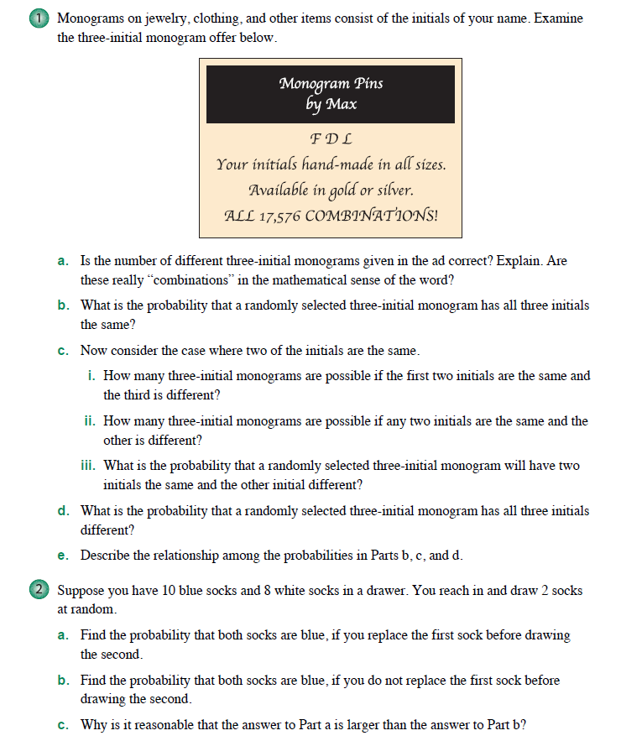

OVER 🡪

